Mini IO Programming Readme

1. First it is required that [Velocio vBuilder](http://velocio.net/vbuilder/) is installed on the computer used to program the mini IO
   * 1. the program is run locally.
2. Connect the Mini IO module to the USB Cable and power cables.
3. Connect the test board to the Mini IO
4. The appropriate firmware load for the Mini IO is stored at: ownCloud\Advance Manufacturing\Test Engineering\LabVIEW\Built\PLC\MiniIO\Firmware\StackLightv1
   1. It is important to note that Vbuilder should be launched by loading the file from this location and should not be copied locally.
      1. This is because the Memory address settings do not copy over appropriately if
   2. In this folder, double click the file named StackLightv1.vio
5. The Velocio Ladder builder will launch and the ladder logic can be observed.
6. Confirm the device is connected and recognized by vBuilder.
   1. This can be done by observing the USB symbol in the bottom right corner of the vBuilder Panel: 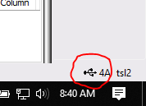
7. With the device connected, click on the program icon:
   1. 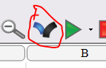
8. The programming should happen quickly.
9. Press the Run Icon
   1. 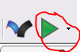
10. Then close Velocio vBuilder.
11. Next, set the config.ini file to operate the MiniIO *without* Light Stack, and with 6 Digital outputs:
    1. [PLC]
    2. Class = MiniIO
    3. Resource = COM3
    4. Calibration = NCR
    5. Digital Inputs = 6
    6. Digital Outputs = 6
    7. Analog Inputs = 0
    8. Analog Outputs = 0
    9. Baud = 19200
    10. Timeout = 1000
    11. ID = 1
    12. Light Stack = False
12. Launch the PLC Unit test software:

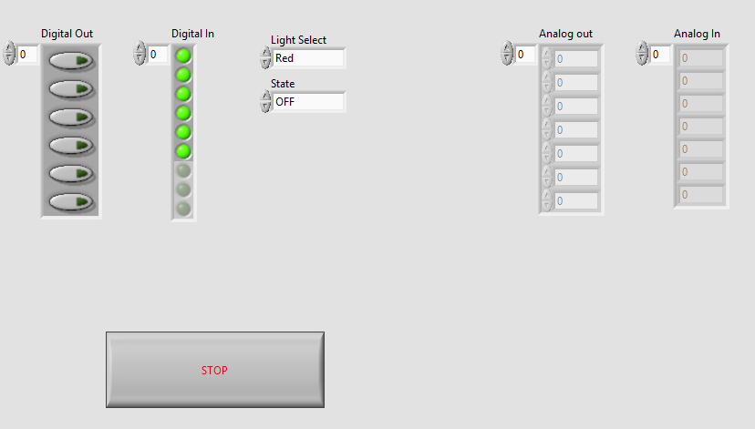

1. The left hand Buttons control the corresponding Digital outputs (1:6)
2. The Left hand indicators display the state of the digital inputs.
3. The light stack controls are inoperable in the current configuration because the software is configured to ignore light stack operation.
4. Toggle each of the digital outputs and verify the corresponding LEDs turn on:
   1. 1 = Red
   2. 2 = Amber
   3. 3 = Green
   4. 4 = first clear LED
   5. 5 = second clear LED
   6. 6 = Third clear LED
5. Toggle the DIP switches on the board and verify the corresponding Digital Input states update in the PLC Unit test software
6. Stop the Program and configure the Mini IO to operate the Light Stack with 2 digital outputs”
   1. [PLC]
   2. Class = MiniIO
   3. Resource = COM3
   4. Calibration = NCR
   5. Digital Inputs = 6
   6. Digital Outputs = 2
   7. Analog Inputs = 0
   8. Analog Outputs = 0
   9. Baud = 19200
   10. Timeout = 1000
   11. ID = 1
   12. Light Stack = True
7. Save the file and re-lauch the PLC Unit Test

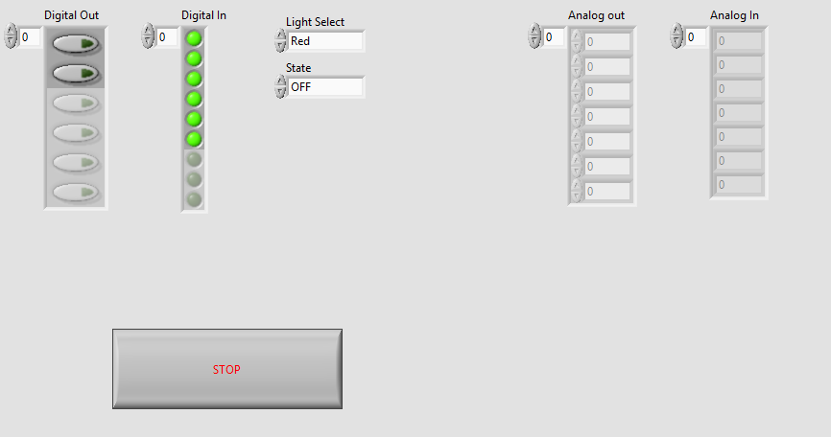

1. The available digital outputs should update and only show 2 available outputs.
   1. Channels 1:4 are now reserved for light stack operation.
2. Channels 5:6 are now considered channels 1 & 2
3. Digital input has no change
4. Light stack controls now control the behavior of the Red, Amber, Green , and “Blue” LEDs
   1. Blue is the first clear led
5. The lights can be configured to operate in nearly any state concurrently with the following exception:
   1. If the red light is *on* or *Blinking* the green light will *always* be off, no matter what commands are sent to green
   2. When the red light is off, green will operate as commanded
   3. If the red light is turned to either on or blinking and the green light is on or blinking, the green light will be forced to the off state.
6. After verifying the functionality described in the previous steps, it is confirmed that the MiniIO is programmed and operational.